A Major Project Phase-II Report On

## Privacy-Preserving Graph Spectroscopy

Submitted in partial fulfillment of the requirements for the award of the

## Bachelor of Technology

In

**Department of Computer Science and Engineering**

By

## Student Names Roll Numbers

Kandur Sowmya 21241A0593

Kalwakota Sreeja 21241A0592

Pulluru Deepshika 21241A05B5

Divya Javvaji 21241A05A0

Under the Esteemed guidance of

**Dr. K. ButchiRaju**

** Professor & Dean(T&P)**

**Department of Computer Science and Engineering**

**GOKARAJU RANGARAJU INSTITUTE OF ENGINEERING AND TECHNOLOGY**

**(Autonomous)**

**Bachupally, Kukatpally, Hyderabad, Telangana, India, 500090**

**2024-2025**



# GOKARAJU RANGARAJU INSTITUTE OF ENGINEERING AND TECHNOLOGY

**(Autonomous)**

# CERTIFICATE

**This is to certify that the major project phase-I work entitled “Privacy-Preserving Graph Spectroscopy” is submitted by Kandur Sowmya (21241A0593), Kalwakota Sreeja (21241A0592), Pulluru Deepshika (21241A05B5), Divya Javaji (21241A05A0) in partial fulfillment of the award of a degree in BACHELOR OF TECHNOLOGY in Computer Science and Engineering during the academic year 2024-2025.**

HEAD OF THE DEPARTMENT

**Dr.B.SANKARA BABU**

**Professor & Head**

GUIDE

**Dr. K.Butchi Raju**

**Professor & Dean (T&P)**

**EXTERNAL EXAMINER**



Many people helped us directly and indirectly to complete our project successfully. We would like to take this opportunity to thank one and all. First, we wish to express our deep gratitude to our guide **Dr. K. Butchi Raju**, **Professor**, Department of CSE for his support in the completion of our project work Phase-I successfully and for all the time to time guidance provided to us**.** The process made us to learn a lot practically and we are very thankful to the final year Project Coordinator **Dr. N. Krishna Chythanya**, Asst. Prof., CSE and our class project coordinator **Ms. Suneetha** Assistant Professor, CSE for their unwavering support in providing schedules, formats, rubrics and arranging the seminars at regular intervals. Our Sincere thanks to Project Review Committee Member **Dr. G. Ramesh, Associate Professor**, CSE, for his in-depth analysis during evaluations of seminars that helped us in improvising the quality of our work. We wish to express our honest and sincere thanks to **Dr. B. Sankara Babu, HOD,** Department of CSE, to our Principal **Dr. J. Praveen** and to our Director **Dr. Jandhyala N Murthy** for providing all the facilities required to complete our major project Phase-I. We would like to thank all our faculty and friends for their help and constructive criticism during the completion of this phase. Finally, we are very much indebted to our parents for their moral support and encouragement to achieve goals.

**Student Names (Roll Numbers)**

Kandur Sowmya (21241A0593)

Kalwakota Sreeja (21241A0592)

Pulluru Deepshika (21241A05B5)

Divya Javvaji (21241A05A0)

# DECLARATION

We hereby declare that the major project phase-I entitled “**Privacy-Preserving Graph Spectroscopy**” is the work done during the period from **2024-2025** and is submitted in the partial fulfillment of the requirements for the award of the degree of Bachelor of Technology in Computer Science and Engineering from **Gokaraju Rangaraju Institute of Engineering and Technology (Autonomous).** The results embodied in this phase-I of project have not been submitted to any other University or Institution for the award of any degree or diploma.

**Student Names (Roll Numbers)**

Kandur Sowmya (21241A0593)

Kalwakota Sreeja (21241A0592)

Pulluru Deepshika (21241A05B5)

Divya Javvaji (21241A05A0)

|  |  |  |
| --- | --- | --- |
|  | **Table of Contents** |  |
| **Chapter** | **TITLE** | **Page No.** |
|  | Abstract | 1 |
| 1 | Introduction | 2 |
| 2 | Literature Survey | 3 |
| 2.1 Introduction | 3 |
| 2.2 Related Work | 3 |
| 2.3 Gaps Identified | 10 |
| 2.4 Problem Statement | 11 |
| 2.5 Proposed Solution | 1 |
| 2.6 Summary | 11 |
| 3 | System Requirements Specification | 12 |
| 3.1 Introduction | 12 |
| 3.1.1 Purpose | 12 |
| 3.1.2 Scope | 12 |
| 3.1.3 Definitions, Acronyms and Abbreviations | 13 |
| 3.1.4 References | 14 |
| 3.1.5 Overview | 14 |
| 3.2 General Description | 14 |
| 3.2.1 Product Perspective | 15 |
| 3.2.2 Product Functions | 15 |
| 3.2.3 User Characteristics | 15 |
| 3.2.4 General Constraints | 16 |
| 3.2.5 Assumptions and Dependencies | 16 |
| 3.3 Specific Requirements | 17 |
| 3.3.1 Functional Requirements | 17 |
| 3.3.2 Non- Functional Requirements | 18 |
| 3.3.3 User Interface Requirements | 19 |
| 3.3.4 Metadata and Schema of Database | 19 |
| 3.3.5 Hardware/Software Requirements | 20 |
| 3.4 Architecture and UML Diagrams | 22 |
| 3.4.1 Architecture Diagram | 22 |
| 3.4.2 Use Case Diagram | 23 |
| 3.4.3 Class Diagram | 24 |
| 3.4.4 Sequence Diagram | 25 |
| 3.5 Summary | 26 |
| 4 | Methodology | 27 |
| 4.1 Modules | 27 |
| 4.2 Methodology Proposed for Solution Implementation. | 28 |
| 4.3 Metrics Used For Results Evaluation | 30 |
| 4.4 Summary | 31 |
|  | Testing & Results | 33 |
|  | 5.1 Unit Testing | 33 |
| 5 | 5.2 System Testing | 33 |
|  | 5.3 User Acceptance Testing | 36 |
|  | 5.4 Results | 37 |
| 6 | Conclusion and Future Scope | 39 |
| 5.1 Conclusion | 39 |
| 5.2 Future Scope | 39 |
|  | References | 41 |

|  |  |  |
| --- | --- | --- |
|  | **LIST OF TABLES** |  |
| **Table No** | **Table Name** | **Page No** |
| 2.2 | Literature Survey | 7 |
| 3.3.4 | Data Set | 20 |
| 5.1 | Unit Testing | 33 |
| 5.3 | User Acceptance Testing | 36 |

|  |  |  |
| --- | --- | --- |
|  | **LIST OF FIGURES** |  |
| **Fig No** | **Fig Title** | **Page No** |
| 3.4.1 | Architecture Diagram | 22 |
| 3.4.2 | Use Case Diagram | 23 |
| 3.4.3 | Class Diagram | 24 |
| 3.4.4 | Sequence Diagram | 25 |
| 5.4 | Results | 37 |

# ABSTRACT

With the accelerated growth of graph-structured data in many domains—healthcare, finance, and social networks, among others—there is a growing need for privacy-preserving analytical frameworks. This project, Privacy-Preserving Graph Spectroscopy, introduces a new and secure computational framework that combines graph spectral analysis, state-of-the-art encryption, and graph-based machine learning to yield valuable insights while maintaining data confidentiality. The paradigm follows a formal pipeline of data preprocessing, graph construction, and spectral decomposition through Laplacian matrix analysis. For dealing with privacy concerns due to sensitive spectral features (e.g., eigenvectors), the paradigm follows the use of AES-GCM encryption, ensuring secure transmission and storage of graph features and preventing potential inference attacks.

These encrypted spectral features are subsequently passed into a Graph Neural Network (GNN) classification model, implemented with PyTorch Geometric (PyG). The GNN learns node embeddings and does structural classification on the graph without maintaining the privacy of the underlying data. Additionally, the platform features secure graph visualization with Streamlit and Pyvis and offers a friendly interface for interaction with encrypted graphs. Remote access is secured through Cloudflared tunneling, which enables authorized individuals to traverse through the data in real time without any chance of unauthorized exposure.

The proposed framework ensures end-to-end security through high-strength encryption mechanisms and access control procedures. Modular design makes it scalable and efficient, adaptable to large graph analysis tasks in mission-critical domains where data sensitivity is dominant.

In the future, the framework may be augmented with cutting-edge privacy technologies such as Differential Privacy and Fully Homomorphic Encryption (FHE) in order to enhance its capability to perform privacy-aware analytics with little compromise on data fidelity.

**Keywords:** Graph Spectral Analysis, Privacy-Preserving Computation, AES-GCM Encryption, Graph Neural Networks, PyTorch Geometric, Homomorphic Encryption, Healthcare Graphs, Secure Visualization, Edge Computing, Differential Privacy.

# 1.INTRODUCTION

With recent years witnessing rapid exponential growth in graph-structured data in several fields—bioinformatics, health analytics, finance systems, and social networks—there has been an increased recognition of the imperative to employ powerful computational techniques in extracting meaningful patterns. Specifically, research into the analysis of protein-protein interaction (PPI) networks within biotechnology has gained paramount significance in elucidating disease pathways, drug interactions, and gene functions. Graph-structured machine learning, particularly involving Graph Neural Networks (GNNs), has come to emerge as a promising paradigm for the modeling of complex relations.Among several different analysis techniques, spectral graph theory, which takes advantage of the eigenvalues and eigenvectors of matrices like the graph Laplacian, presents strong ability to analyze structural graph properties. Some of its applications are community detection, clustering, graph partitioning, and anomaly detection. But the sensitive nature of most real-world graphs (e.g., medical data or social networks) poses severe privacy issues. It is possible for spectral features to be employed in inference attacks, revealing confidential relationships and identities in the data.The process starts with protein interaction data loading and preprocessing, then building a weighted graph based on the NetworkX library. The graph Laplacian matrix is calculated, and eigen decomposition is applied to obtain spectral features like eigenvectors. To safeguard against privacy breaches, the eigenvectors are encrypted by AES-GCM (Advanced Encryption Standard in Galois/Counter Mode), a symmetric encryption technique that provides both confidentiality and integrity during storage and transmission of data.

After being encrypted, the system uses a Graph Convolutional Network (GCN) model—coded with PyTorch Geometric (PyG)—to learn graph representations and execute operations such as node classification. The nodes are given synthetic labels and random features for demonstration purposes. In spite of the privacy protocols, the system is still strong in learning, with high accuracy when it comes to classifying graph structures.One of the major strengths of the project is its secure visualization interface, implemented with Streamlit and Pyvis, through which users can decrypt and investigate graph structures using a web interface. Cloudflared tunneling is utilized to facilitate remote and encrypted access so that the system can be utilized in distributed or collaborative research setups. Access to spectral information is controlled strictly via decryption key authentication so that only valid users can see sensitive features.

# 2.LITERATURE SURVEY

## Introduction

The accelerated growth of sensitive biomedical information—especially in healthcare systems and bioinformatics—has highlighted the critical need for sophisticated computational models that facilitate meaningful analysis of data while maintaining robust privacy safeguards. Graph-based data modeling has become an influential paradigm for capturing intricate relationships, where proteins, genes, patients, treatments, or medical events are encoded as nodes and their interactions as edges. For instance, protein-protein interaction (PPI) networks are widely applied in molecular biology to reveal functional modules, infer interactions, and understand mechanisms of disease.

To counter this, the project proposes Privacy-Preserving Graph Spectroscopy, a secure and scalable framework that makes use of spectral graph theory combined with AES-GCM encryption to safeguard sensitive spectral features—namely, eigenvectors from Laplacian matrix decomposition. These encrypted features are then used in Graph Neural Network (GNN) models deployed through PyTorch Geometric (PyG), supporting privacy-preserving node classification and pattern detection. Compared to computationally demanding solutions such as Fully Homomorphic Encryption (FHE), Differential Privacy, or Secure Multi-party Computation (SMC), this solution achieves a practical compromise between security, scalability, and machine learning usability. An encrypted graph visualization capability, enabled by Pyvis and Cloudflared tunneling-supported secure Streamlit-based interface, is provided by key-based access control.

## 2.2Related Work

1. **Private Graph: Privacy-Preserving Spectral Analysis of Encrypted Graphs in the Cloud**

The paper "PrivateGraph: Privacy-Preserving Spectral Analysis of Encrypted Graphs in the Cloud" introduces a technique for conducting spectral analysis on graph data that is encrypted. This enables users to extract valuable insights while ensuring their privacy is preserved. Nonetheless, there are various limitations to consider. Firstly, the additional computational demands of the encryption and decryption processes may result in higher latency. Secondly, the approach might encounter challenges when dealing with large-

cloud environments. Lastly, the accuracy of the spectral results could be influenced by the encryption, which might lead to potential inaccuracies in the analysis.

## Locally Private Graph Neural Networks

The paper titled "Locally Private Graph Neural Networks" is authored by Sina Sajadmanesh and Daniel Gatica-Perez. It addresses issues of privacy considering graph data learning, especially when the nodes contain sensitive information. The authors propose a GNN algorithm that preserves privacy through utilizing Local Differential Privacy (LDP). This algorithm features an LDP encoder and an unbiased rectifier, which assist secure data communication. A new KProp graph convolution layer acts as a denoising mechanism to reduce privacy-related noise, enabling the model to achieve accuracy with minimal loss of privacy. Despite these advantages, the method may face challenges regarding scalability with exceptionally large graphs. What's more, the noise fundamental to LDP could still affect the performance of the model on complex tasks. Besides, the architecture-agnostic nature of this approach may hinder optimization for specific GNNs, thereby complicating the practical implementation and management of privacy parameters. Striking a balance between privacy guarantees and utility continues to be a major challenge**.**

## Benchmarking Differentially Private Graph Algorithms

The paper titled "Benchmarking Differentially Private Graph Algorithms,"assesses the accuracy, performance, and scalability of differentially private algorithms for graph analysis using real-world datasets. The authors emphasize that selecting the most suitable algorithm is highly dependent on the characteristics of the dataset and specific privacy requirements. They stress the importance of having a standardized benchmarking platform to support practitioners in choosing from the wide range of available options. Nonetheless, the study's results may not be broadly applicable because they are influenced by the dataset used. What's more, some algorithms still encounter scalability challenges when dealing with large datasets. The complexities involved in implementation, which arise from diverse configurations, can also impede practical applications. Lastly, the low adoption rates indicate that there are obstacles that extend beyond just technical performance.

## Privacy-Preserving Constrained Spectral Clustering Algorithm for Large- Scale Data Sets

This paper presents a new algorithm for clustering called the privacy-preserving constrained spectral clustering algorithm (DP-CSC). This algorithm incorporates differential privacy into spectral clustering by using the Wishart mechanism to ensure differential privacy while still being effective in clustering. The experimental results show that DP-CSC provides satisfactory accuracy and efficiency when tested on five real-world datasets. However, implementing differential privacy may affect the accuracy of clustering, particularly when dealing with sensitive data. Besides, the algorithm may perform less effectively when working with larger datasets or more complex dimensions, and needing careful tuning of privacy parameters can make practical application challenging. Lastly, the conclusions drawn are based on a limited selection of datasets, which might not adequately reflect all possible scenarios or types of data.

## Learning to Fix Build Errors with Graph2Diff Neural Networks

The paper "Learning to Fix Build Errors with Graph2Diff Neural Networks" presents Graph2Diff, a deep learning architecture designed to automatically localize and fix build errors by representing source code, build configurations, and compiler messages as graphs. Using a Graph Neural Network, it predicts diffs that specify modifications to the abstract syntax tree, demonstrating significant improvements in accuracy over the existing Deep Delta method on a dataset of over 500,000 real build errors. However, the model may struggle with complex diffs requiring extensive contextual understanding, and its performance heavily depends on the quality of training data. Additionally, the approach may not generalize well across different programming languages or frameworks, and the inherent complexity of deep learning models can reduce interpretability, potentially undermining user trust in its suggestions.

## Privacy-Preserving Spectral Analysis of Large Graphs in Public Clouds

The document titled "Privacy-Preserving Spectral Analysis of Large Graphs in Public Clouds" offers a framework designed to securely analyze large graph datasets while safeguarding sensitive information. It proposes two privacy-preserving algorithms for approximate eigen decomposition and a differential privacy-based technique for data submission. This allows for efficient operations on the client side while delegating more intensive computations to the cloud. Nevertheless, the method may encounter challenges related to algorithmic complexity when dealing with extremely large graphs. It also faces potential trade-offs between data sparsity and utility, depends on the trustworthiness of the cloud, and has limited applicability to a variety of graph structures or tasks

## CryptGraph: Privacy Preserving Graph Analytics on Encrypted Graph

The paper "CryptGraph: Privacy Preserving Graph Analytics on Encrypted Graph" presents a framework that allows users to perform graph analytics on encrypted data, ensuring user privacy by keeping sensitive information inaccessible to the cloud. By employing homomorphic encryption, the framework supports computations on encrypted graphs, allowing users to upload and analyze their data without decryption. However, this approach introduces significant computational overhead, may complicate the implementation of certain graph algorithms, raises scalability concerns with large graphs, and places an additional burden on users to manage encryption decryption.

## A Survey on Privacy in Graph Neural Networks: Attacks, Preservation, and Applications

The paper "A Survey on Privacy in Graph Neural Networks: Attacks, Preservation, and Applications" offers a thorough examination of privacy issues in Graph Neural Networks (GNNs), categorizing various attacks and reviewing techniques for preserving privacy while balancing utility. However, it may not encompass all emerging threats or techniques due to the field's rapid evolution, and it lacks detailed implementation insights for privacy-preserving methods. Additionally, its focus on existing approaches may limit the exploration of novel strategies, and the discussed datasets might not fully represent real-world applications.

## Private social network analysis: how to assemble pieces of a graph privately

The paper titled "Private Social Network Analysis: How to Assemble Pieces of a Graph Privately" addresses the issue of reconstructing complex graphs from distributed data while protecting participant privacy. It emphasizes privacy threats, especially from malicious nodes that might supply false information to assist de-anonymization. The authors propose secure protocols designed to restrict the capabilities of adversaries. Nevertheless, these protocols can be complex and require important resources to implement. Also, there may be scalability challenges when assembling large-scale graphs involving many participants. Besides, the model might not consider all forms of malicious behavior, which could impact privacy. Lastly, there may be a trade-off between ensuring privacy and achieving the accuracy or completeness of the reconstructed graph.

## Federated Multi-View Spectral Clustering

This paper presents Federated Multi-View Spectral Clustering (FMSC), a secure and distributed framework that enables multi-view spectral clustering while safeguarding participant data privacy. FMSC allows various parties to collaborate on clustering tasks without exposing their data, addressing the privacy issues linked with centralized methods, especially in sensitive fields such as healthcare and finance. The framework uses principles from federated learning, incorporating Homomorphic Encryption and Differential Privacy to maintain the security of the clustering process. Comprehensive experiments show that FMSC yields competitive clustering results when compared to traditional centralized techniques, emphasizing its effectiveness in both real-world and synthetic datasets.

## Literature Survey Table

|  |  |  |  |
| --- | --- | --- | --- |
| **S.NO** | **Title of Publication** | **AIM/Objective** | **Year** |
| 1 | Private Graph: Privacy- Preserving Spectral Analysis of Encrypted Graphs in the Cloud | Introduces a technique for conducting spectral analysis on graph data  that is encrypted. | 2022 |
| 2 | Locally Private Graph Neural Networks | It addresses issues of privacy considering graph data learning, especially when the nodes contain  sensitive information. | 2019 |
| 3 | Benchmarking Differentially Private Graph Algorithms | Assesses the accuracy, performance, and scalability of differentially private algorithms for graph analysis using real-world  datasets. | 2021 |
| 4 | Privacy-Preserving Constrained Spectral Clustering Algorithm for Large-Scale Data Sets | An algorithm for clustering called the privacy-preserving constrained spectral  clustering algorithm. | 2018 |
| 5 | Learning to Fix Build Errors with Graph2Diff Neural Networks | Presents Graph2Diff to automatically localize and fix build errors by representing source code  as graphs | 2022 |
| 6 | Privacy-Preserving Spectral Analysis of Large Graphs in Public Clouds | Offers a framework designed to securely analyze large graph datasets while safeguarding sensitive  information. | 2021 |
| 7 | CryptGraph: Privacy Preserving  Graph Analytics on Encrypted | Presents a framework that  allows users to perform | 2020 |
|  | Graph | graph analytics on encrypted data, ensuring user privacy by keeping sensitive information  inaccessible to the cloud. |  |
| 8 | A Survey on Privacy in Graph Neural Networks: Attacks, Preservation, and Applications | Offers a thorough examination of privacy issues in GNNs, categorizing various attacks and reviewing techniques for preserving  privacy. | 2019 |
| 9 | Private social network analysis: how to assemble pieces of a graph privately | Addresses the issue of reconstructing complex graphs from distributed data while protecting  participant privacy. | 2018 |
| 10 | Federated Multi-View Spectral Clustering | A secure and distributed framework that enables multi-view spectral clustering while safeguarding participant  data privacy | 2019 |

**2.3 Gaps Identified**

Despite the advancements in graph analytics and privacy-preserving techniques, several critical gaps

persist that hinder their effective application in healthcare settings:

## Privacy Concerns

Current graph analytics methodologies often fall short in addressing privacy, leaving sensitive healthcare data vulnerable during processing. Patient records, treatment histories, and doctor-patient interactions represent highly sensitive information that, if exposed, can lead to significant privacy violations and breaches of regulations such as HIPAA and GDPR. The absence of built-in privacy mechanisms in traditional systems exacerbates the risks, particularly in scenarios where data needs to be shared across institutions or analyzed in untrusted environments. This gap emphasizes the urgent need for integrating robust privacy-preserving technologies like Fully Homomorphic Encryption (FHE) into graph analytics workflows.Computational Overhead

While FHE provides an unmatched level of security by allowing computations directly on encrypted data, it comes at a steep computational cost. The encryption and subsequent operations on encrypted data are resource-intensive, resulting in significant delays. This high latency makes FHE impractical for real-time applications or scenarios requiring the processing of large datasets, such as population- scale healthcare networks or real-time predictive analysis. The computational overhead creates a barrier to scaling these solutions for practical, everyday use in healthcare environments.

## Lack of Scalability

Managing large-scale healthcare graphs, which can consist of millions of nodes and edges representing patients, doctors, treatments, and their interrelations, remains a formidable challenge. Existing systems often struggle to balance the need for computational efficiency, privacy preservation, and scalability. As the size of healthcare datasets grows due to advances in data collection methods like electronic health records and IoT-enabled medical devices, the inability to handle these expansive datasets effectively limits the utility of current frameworks. Developing scalable architectures that can process such graphs without compromising privacy or performance is a pressing need.

## Integration Challenges

Integrating privacy-preserving encryption methods like FHE with advanced analytics techniques such as graph analytics and Graph Neural Networks (GNNs) into a cohesive framework is largely uncharted territory. These technologies have distinct operational requirements, and ensuring they interact seamlessly while maintaining system efficiency and usability presents a significant challenge. For example, GNNs require specific inputs derived from graph features, which must be extracted and processed without exposing sensitive data. Developing a unified system that harmonizes these technologies without compromising security, performance, or user accessibility is a complex but crucial task for advancing healthcare analytics.

Addressing these gaps is essential for creating robust, privacy-preserving solutions capable of handling the growing demands of healthcare analytics while safeguarding sensitive data

* 1. **Problem Statement**

“Privacy-Preserving Graph Spectroscopy’’ is focused on the essential problem of conducting spectral analysis on vulnerable graph-structured data while maintaining privacy. Graphs find extensive applications across fields like bioinformatics, healthcare, social networks, and communications to represent relationships between entities. Spectral methods such as Laplacian decomposition, eigenvalue analysis, and eigenvector extraction are the most important tools for operations such as clustering, classification, and community detection.

But using these methods on actual datasets threatens important privacy because spectral features can reveal sensitive structural information even if datasets are anonymized. Adversaries can use inference attacks and reverse-engineer patterns or relationships from eigenvectors, compromising sensitive information.

The primary issue is the susceptibility of conventional spectral analysis methods to such attacks. Consequently, there exists a necessity for a secure model that provides secure spectral graph analysis without compromising data confidentiality.

This project suggests a scalable and secure solution by using AES-GCM encryption to secure the eigenvectors obtained through spectral analysis. These encrypted features are utilized in a Graph Neural Network (GNN) constructed using PyTorch Geometric, supporting privacy-aware operations such as node classification and link prediction.

The project also enables interactive and secure graph visualization using Streamlit and Pyvis, with access limited through decryption key authentication. Although superior methods such as differential privacy or homomorphic encryption are feasible, this solution provides an efficient, lightweight, and scalable solution that can be applied to real-world applications

## 2.5 Proposed Solution

The solution presented for Privacy-Preserving Graph Spectroscopy is to carry out spectral analysis on sensitive graph data without any privacy loss. The system starts by preprocessing biological data, for example, protein-protein interactions, and representing it as a weighted graph through NetworkX.

Spectral features are then extracted via Laplacian matrix decomposition. To safeguard these sensitive eigenvectors, the system implements AES-GCM encryption, ensuring confidentiality, integrity, and secure transmission of data.

These encrypted properties are subsequently applied in Graph Neural Network (GNN) models that are adopted using PyTorch Geometric (PyG), enabling node classification and pattern detection without exposing sensitive information.

In order to keep data exposure minimal, edge computing is utilized—local processing occurs, lessening the requirement for sending raw data. Streamlit-based UI, integrated with Pyvis, delivers interactive graph visualization, and Cloudflared tunneling provides safe, remote viewing. Authenticated users possessing a valid decryption key can see or examine the graph structure.

Lightweight, modular in nature, it is highly scalable and most suitable for privacy-critical fields such as healthcare, finance, and social networks.

## Summary

This section gives an overview of the current state of knowledge and outlines key challenges in privacy-preserving healthcare data analytics. The suggested solution has the intention to bridge these gaps by creating an integrated solution based on edge computing, AES-encryption, and graph analytics techniques.

# 3.SYSTEM REQUIREMENTS SPECIFICATION

## Introduction

The Privacy-Preserving Graph Spectroscopy Framework provides a new and efficient solution to privacy-preserving analytics in healthcare systems and bioinformatics. The reason for its development is to reconcile the analytical value of sensitive healthcare information with the use privacy and security laws that regulate its use. In contrast to existing methods that sacrifice either efficiency or privacy, this system combines edge computing, AES-GCM encryption, and graph-based deep learning models with Graph Neural Networks (GNNs). The framework guarantees the protection of sensitive graph features—i.e., eigenvectors derived from spectral graph analysis—across storage, transmission, and analysis

## Purpose

This system is intended primarily to allow health care organizations to perform meaningful analysis on encrypted records in a way that honors the rules of patient privacy. The main goals of this framework are:

3.1.1.1 To offer a scalable solution that facilitates processing large encrypted graphs relative to health care.

3.1.1.2 Utilization of graph machine learning to discover hidden patterns while being able to predict patient outcomes and evaluate treatment efficacy.

3.1.1.3 Guarantee sensitive data is never disclosed or deciphered, even during processing or transmission.

The framework is designed to be utilized by health care organizations, research organisations and data analyzers for health analytic privacy-centric analytics for sensitive information.

## Scope

The Privacy-Preserving Graph Spectroscopy Framework addresses the fundamental challenges associated with the secure evaluation of bioinformatics and healthcare graph datasets, e.g., protein-protein interaction (PPI) networks, intending to keeping sensitive material confidential along with executable analytics using spectral approaches and graph-based ML methods.

**The most important features include**:

**Data Privacy:** The framework utilizes an AES-GCM encryption module thereby ensuring that any sensitive spectral features, including eigenvectors, remain securely encrypted while being stored, transferred and processed.

**Scalability**: The use of spectral decomposition and GNN training results in local information so only limited amounts of raw data are transmitted to the centre. Local decision making for data processing is optimal for large biological graphs.

**Actionable Insights**: Spectral analysis and GNNs in combination provide many more expected results; node classification, structure discovery (subgraphs) and patterns of interactions within PPI networks.

**Secure Data Transmission**: Even though the solution performs localised execution, it may still be securely accessed through tunnelling with Cloudflared or using "ngrok" to protect the data while in transit during remote access.

**Regulatory Alignment:** While the regulatory process is not directly integrated into the system but it adheres to key principles of GDPR and HIPAA in protecting identifiable data (especially, encryption of data, access controls, minimal exposure of raw data).

This solution is especially useful for applications dealing with sensitive biomedical data, including:

* + - Genomic studies and protein analysis
    - Clinical graph-based predictions
    - Patient treatment pattern mining
    - Privacy-preserving biological network visualization

## Definitions, Acronyms, and Abbreviations

## AES-GCM: Advaned Encryption Standard – Galois/Counter Mode, employed for authenticating encrypted spectral features.

## GNN: Graph Neural Network – a deep neral network architecture employed for processing graph-structured information.

## PyG: PyTorch Geometric – a PyToch package employed for performing GNN operations in Python.

## Laplacian Matrix: A graph format employd for representing spectral features such as eigenvalues and eigenvectors.

## Eigenvalues/Eigenvectors: Fundamental outputs of spectral decompsition utilized for comprehending graph structure.

## PPI: Protein-Protein Interction – networks describing biological interactions among proteins.

## Cloudflared: A safe tuneling service to securely expose local applications to the internet.

## Streamlit: A Python framework employed to develp safe, interactive data visualization apps.

## 

## References

1.PyCryptodome Documentation – The cryptographic library for the AES-GCM implementation,documentation can be accessed at:pycryptodome.org  
2. PyTorch Geometric Documentation – The toolkit for GNN implementation can be accessed at: pytorch-geometric.readthedocs.io/en/latest/  
3. Spectral Graph Theory Research – This is some academic references to support the Laplacian base graph analyses.   
4. Cloudflare/Cloudflared Documentation – Intended for secure application tunneling, documentation can be found at:docs.cloudflare.com  
5. GDPR & HIPAA Guidelines – Regulatory frameworks that have served as foundations for the privacy practices used as guidance for the system design.

## 3.1.5 Overview

This document covers the system's intended purpose, scope, and architecture. It also details functional and non-functional requirements, user interface requirements, and the hardware/software dependencies. The architecture diagram and UML diagrams provide insight in regard to the system use-case and its components.

## 3.2 General Description

The Privacy-Preserving Graph Spectroscopy Framework is an encrypted, large-scale framework that addresses the dual problem of data privacy and analytical efficiency for sensitive domains such as healthcare and bioinformatics. In particular, the framework looks to analyze graph-structured data - for example protein-protein interaction (PPI) networks - based on spectral graph analysis and graph neural networks (GNNs), while ensuring the privacy and security of sensitive information using AES-GCM encryption.

The framework's architecture mimics an edge-aware architecture whereby the data is locally pre-processed, sanitized, and encrypted at the data source to minimize the exposure of the unencrypted, raw data. The encrypted spectral features (eigenvectors) can then be used for learning and visualisation with secure tools such as PyTorch Geometric (for GNN training) and Streamlit (for visualisation) through Cloudflared tunneling allowing for remote encrypted access.

## 3.2.1 Product Perspective

This mechanism offers a promising alternative to the problems with traditional healthcare analytics platforms that are usually at risk of privacy breaches while at best providing modest scaling benefits. Rather than being constructed on a centralized method of data aggregation, the proposed mechanism is designed assuming the data is locally pre-processed with spectra feature encryption, and privacy-aware graph learning. Moreover, while fully homomorphic encryption (FHE) is not available at this time, the mechanism utilizes AES-GCM method for authenticated encryption and secure storage, which makes it practical, strong and lightweight for the application use cases outlined in the previous sections. The modular design allows it to be incorporated into existing infrastructures in which clinical data are produced and stored, processes such as:

1. Load and clean data

2. Build graph (via NetworkX)

3. Conduct spectral analysis (via Laplacian decomposition)

4. Encrypt with AES-GCM

5. Train model (GNN via PyG)

6. Visualize (secure via Streamlit & Pyvis).

## 3.2.2 Product Functions

The system allows for the following primary features:

* **Data Preprocessing**: Cleaning and formatting of raw biological data, sampling of interactions, and duplicate identification
* **Spectral Analysis**: Construction of Laplacian matrices and extraction of their eigenvalues and eigenvectors to derive graph properties
* **Feature Encryption**: Segments of the encrypted spectral features encrypted using AES-GCM for sensitive embeddings
* **ML using GNNs**: Authors node classification and embedding learning to work with PyTorch Geometric
* **Secure Visualization**: Users decrypted to visualize encrypted graphs using a specifically built Streamlit and Cloudflared interface**.**

## User Characteristics

This framework supports a diverse group of users with varying bioinformatics, healthcare and IT expertise:

* Healthcare Researchers: Professionals who study the biological interaction networks, not the original raw data.
* Data Scientists: Users who develop predictive models on encrypted graph data
* IT & Security Teams: Who are accountable for rolling out, maintaining, and protecting the application.
* Regulatory Reviewers: By reviewing access notices and logs - and undertaking secure reviews of our application, e.g., ensuring we are compliant with the GDPA and HIPAA.

The users access the system either through an interface or scripts, and for the technical teams, full support for any secure key management and configuration is provided as they use the system..

## General Constraints

This system is affected by the following restrictions:

* Encryption Overhead: While less heavy than FHE, AES-GCM still has compute operations to tack on to feature processing and visualization.
* Key Management: Likewise, it is essential to be conscious of securely managing the AES key to ensure that it is stored and protected to ultimately provide the correct decryption.
* Graph Size: Very large biological graphs will require extended compute time for Laplacian decomposition and using the GNN to train the model.
* Reliance on Data Quality: Results and predictions are directly related to the extent and quality of the graph data that is provided to the system.

## Assumptions and Dependencies

The following assumptions will be made for successful deployment and operation:

* Reliable Network Access: That Cloudflared tunneling during deployment, and for data visualization, is reliable for Internet access and access during deployment.
* Adequate Local Resources: data is assumed to be living in local (edge-like) environments to do local preprocessing, encrypting, and training lightweight GNN models.
* Use of Secure Libraries: the system (libraries included but not limited to PyCryptodome (AES), PyTorch Geometric, and NetworkX) is assumed to be secure
* Data Compliance: Input datasets are assumed to be pre-approved to have been processed under related regulation guidelines which include HIPAA and GDPR.
  1. **Specific Requirements**

**3.3.1Functional Requirements**

**1. AES-GCM Encrypting Spectral Features**

The system must ensure that sensitive spectral data collected from graph-structured health data—the corresponding eigenvectors obtained from Laplacian decomposition—are locally AES-GCM (Advanced Encryption Standard - Galois/Counter Mode) encrypted. AES-GCM is a symmetric encryption process that provides confidentiality, and authentication. This ensures that the spectral data cannot be accessed or altered by unauthorized parties or by humans with a security clearance. The encryption of eigenvectors before storage, or transmission reinforces the ramifications of the inference threat, and will reduce non-compliance with data privacy policies such as HIPAA and GDPR.

**2. Spectral Analysis of Graph Data**

The system will be tasked with performing spectral analysis of sanitized graph data to detect significant features. This would mean calculating the Laplacian matrix as well as the eigenvalues and corresponding eigenvectors as provided with software libraries such as NumPy and SciPy. Spectral analysis is significant because it facilitates insights into the graph's topology and structure i.e., community discovery, recognition of clusters, and connectivity of a graph across data. This analysis is performed prior to the encryption stage to save computation times with an unalterable security wall following.

**3. Graph Neural Network (GNN) Prediction**

The solution must incorporate GNN models that use the PyTorch Geometric (PyG) library to perform predictive tasks like node classification, link prediction, or embeddings. The GNN model was trained using synthetic labels and random node features on the current prototype, demonstrating that the model can learn from privacy-aware or encrypted data. It is necessary to develop models like this that can operate on graph data without exposing raw features during training or inference.

**4. Lock Down Remote Access and Delivery through Cloudflared**

Although the existing use case does not require explicit cloud-based transmission, it allows remote access to secure visualizations and analysis results through Cloudflared tunneling. The configuration is a secure proxy, allowing remote access to a Streamlit application UI securely over HTTPS without exposing internal ports. Although it does not depend on SSL/TLS, Cloudflared uses TLS-encrypted tunnels and protects you from general threats like Man-in-the-middle attacks.

## Non-Functional Requirements

**1. Scalability**

The system should be able to process large-scale biological or healthcare graphs effectively. As bioinformatics data, including protein-protein interaction (PPI) networks, increase in size and complexity, the system should be capable of processing thousands to millions of nodes and edges. Although the current prototype operates on a sampled dataset for demonstration, the architecture should be scalable through modular design, parallel data handling, and optimized storage mechanisms. The use of local preprocessing (edge-aware design) reduces data movement, while models can be extended to operate on distributed infrastructures if needed.

**2. Performance**

To provide responsiveness in actual use, the system must reduce latency in critical operations like encryption, spectral decomposition, and GNN model inference. As AES-GCM is much more efficient than Fully Homomorphic Encryption (FHE), the system provides low encryption overhead with high security. Spectral analysis and GNN training are optimized through efficient numerical libraries (e.g., NumPy, SciPy, PyTorch). Processing times must be reasonable for interactive use, allowing healthcare practitioners and researchers to gain insights in a timely manner.

**3. Safety**

Security is fundamental to system design due to the sensitive nature of genomic and healthcare data. All spectral features (or eigenvectors) are encrypted with AES-GCM to protect confidentiality and integrity both in storage and across transmission. The system does not expose raw graph data and only decrypts information on demand using an authenticated session. By employing Cloudflared tunneling, Streamlit is safely presented to expose the visualization interface for viewing, without exposing external ports and limiting the attack surface. Role-based access and secure key management is critical in a production environment.

**4. Ease of Use**

The interface should be easy enough for non-technical users, such as researchers and medical professionals, to access. A Streamlit web interface provides a lightweight, interactive, and navigable interface. Pyvis visualizations allow users to explore encrypted graph structures after those structures have been decrypted. Little training beyond having end users be able to load the data, enter decryption keys, and run an analysis (or see findings) is needed. Usability is enhanced by good titles, legends, and interactive filtering.

**3.3.3 User Interface Requirements**

The user interface must be interactivity-enabled with accessibility as well. The following features are

to be provided:

1. Decryption Control Dashboard: A secure location for the AES-GCM key inputs, allowing for access to decrypted graph embeddings and basic insight.

2. Graph Visualizations: An interactive graphical representation of graph topology and GNN-based outputs rendered in Pyvis.

3. Spectral Data Interpretation: Plots such as eigenvalue distributions for observing structural patterns of the graph.

4. Filter and Search Recommendations: Allow users to select particular nodes, clusters, or feature within a large graph.

5. Secure Access: Integrating with Cloudflared tunneling for encrypted, authenticated access using HTTPS

## Metadata and Schema of Database

The system database holds the following:  
**1. Metadata**The metadata consists of:  
• Graph Identifiers: Tags for identifying datasets (e.g., "PPI_cleaned_graph_v1").  
• Timestamps: Encryption time, feature extraction time, and analysis time.  
• Access Logs: decryption attempts, user input time stamps, and execution logs to track secure access.  
**2. Schema**  
The database schema consists of:  
  
• Encrypted Features Table: Holds AES-GCM–encrypted spectral features (e.g., eigenvectors).  
• Graph Data Table: Holds cleaned and structured graph data (edges, weights).  
• Analysis Results Table: Holds node embeddings from GNNs and classification result

|  |  |  |
| --- | --- | --- |
| **Field** | **Data Type** | **Description** |
| Protien_ID | String | Unique identifier for every protein in the graph. |
| Interaction_Score | Float | Interaction weight (e.g., confidence score). |
| Laplacian_Eigenvalue | Float | Eigenvalue derived from spectral decomposition. |
| Encrypted_Eigenvec | Binary | Encrypted eigenvector feature via AES-GCM. |
| Timestamp | DateTime | Log of when encryption or prediction was done. |
| Access_Granted | Boolean | Indicates whether the proper decryption key was used. |
| Predicted_Label | Integer | Result of the GNN classification (e.g., class 0, 1, or 2). |

## Hardware/Software Requirements

1. **Hardware:**

* Development Machiine (Local Edge/Cloud Setup):
* Mullti-core CPU (Intel i7 or higher)
* Miniimum 16 GB RAM
* GPU suport (e.g., NVIDIA CUDA-compatible) for GNN acceleration

**Optional Deployment Hardware**:

* Lightweight severs or VMs for hosting Streamlit app
* Remote acess enabled through Cloudflared tunnel.

## Software:

**Encryption:**

* PyCrytodome – used to perform AES-GCM encryption and decryption of spectral features.
* NetworrkX – for graph creation and manipulation.
* NumPy, SciPy – for spectral anallysis, eigenvalue/eigenvector computations.

**Machine Learning (GNNs):**

* PyTorch and PyTorrch Geometric (PyG) – for implementing and training the GNN models.

**Visualization and UI:**

* Streamliit – to build the interactive web interface for visualization and user input.
* Pyvvis – for graph visualization
* Cloudflarred – for creating a secure, tunnelled, HTTPS interface for remote usage.

**Others:**

* Matplotliib – for plotting eigenvalue distributions.
  1. Pandas – for tabullar data manipulation and display.Architecture and UML Diagram
     1. **System Architecture**

The architecture is with a secure and modular design for processing and analyzing sensitive healthcare graph data. In the Edge Layer, data are gathered from sources such as patients and doctors, cleaned, and graph-structured with NetworkX. Spectral features like eigenvalues, eigenvectors, and the Laplacian matrix are extracted and locally encrypted using AES-GCM for data privacy before transmission.

The encrypted information is transmitted to the Cloud Layer, where Graph Neural Networks (GNNs) in PyTorch Geometric conduct learning operations such as node classification, and spectral analysis identifies community patterns and structures. All communication is encrypted using Cloudflared tunneling tools.

Lastly, the results are decrypted and displayed via a Streamlit-based interface, while interactive graph visualization is enabled through Pyvis. The multi-layered design ensures end-to-end security, scalability, and analytical depth—making it extremely suitable in applications such as bioinformatics, clinical research, and privacy-preserving healthcare analytics

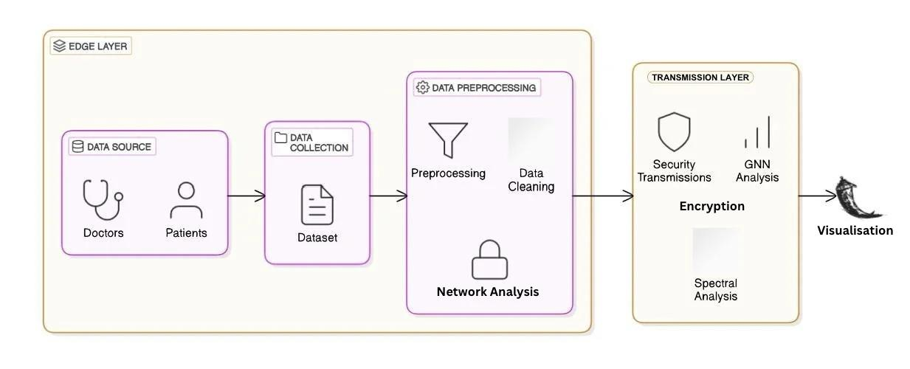

**Figure No. 3.4.1 Architecture Diagram**

## Use Case Diagram

This diagram shows a Privacy-Preserving Data Processing System with a Provider, Edge Node, Cloud, and User. The Provider provides the unclean data which can then be cleaned and pre-processed and encrypted by the Edge Node (edge). It is safe to send the encrypted data to the Cloud to conduct GNN and spectral analysis. The results that are sent back to the User. It is possible to protect privacy of data, secure transfer and commit compute-intense analysis

## 

**Fig No.3.4.2 Use Case Diagram**

* + 1. **Class Diagram**

The flow diagram presents a Privacy-Preserving Data Processing System with a Provider, Edge Node, Cloud Service, and User. The Provider has available the dataset, the Edge Node cleans, preprocesses, encrypts, and securely transfers the dataset. The Cloud provides higher-level analysis like GNN and spectral analysis. The User receives and assesses the results. The process flow should ensure secure processing and analyzing while keeping privacy with potentially distributing aspects.

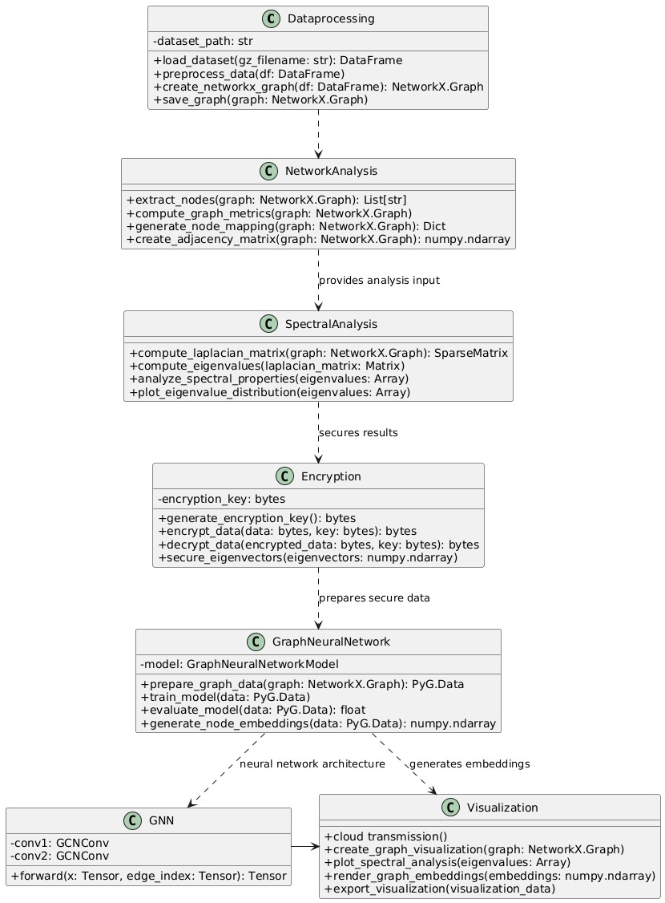

**Fig No.3.4.3 Class Diagram**

## Sequence Diagram

The figure depicts a secure workflow for a Data Processing System involving a Provider, Edge Node, Cloud Service, and User. The Provider operates the data, which will be cleaned, preprocessed, and encrypted by the edge node. The encrypted data will send to the cloud for GNN and spectral analysis. The User will receive the information and assess which processes should be conducted. The process achieves privacy, performs processing securely, and achieves processing and analysis effectiveness through ensuring complete compatibility of edge to cloud.

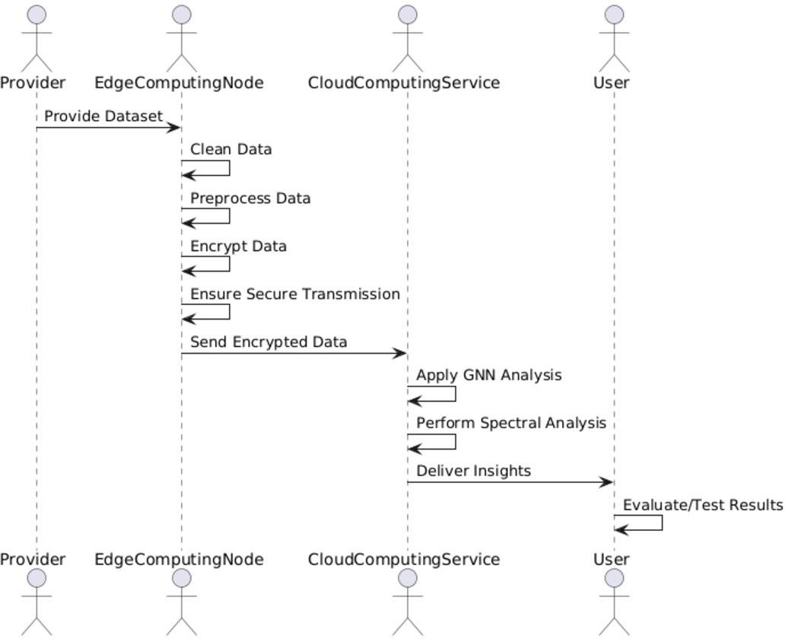

**Fig No.3.4.4 Sequence Diagram**

## 3.5 Summary

The **Private Graph Framework** is designed with a secure, modular architecture to address privacy challenges in healthcare data analysis. UML diagrams effectively demonstrate the system’s components, interactions, and data flow:

* The **Architecture Diagram** provides a high-level overview.
* The **Use Case Diagram** highlights user and system functionalities.
* The **Class Diagram** defines core components and their relationships.
* The **Sequence Diagram** maps the detailed workflow of data processing.

# 4.METHODOLOGY

**4.1Modules**

**1. Data Import and Preprocessing Module**

The Data Import and Preprocessing Module represents the core part of the system because it allows the raw protein interaction data to be imported and cleaned. The module will import the dataset in CSV or compressed formats and will perform the necessary preprocessing. These steps include removing null values, removing duplicates, converting the interaction scores to numeric values, and then sampling the data to reduce the computational load during model training. Once the data is cleaned and processed, it is then mapped in to a graph structure with NetworkX, where the proteins are nodes and the protein-protein interactions are edges with weights of the interaction scores. The organized graph data will subsequently be used as the input in later spectral analysis and encryption, thus the data is organized, optimized, and consistent to be usable for downstream privacy preserving machine learning tasks.

**2. Privacy Mechanisms Module**

The Privacy Mechanisms Module protects sensitive spectral graph features in its data storage and processing aspects. The project uses AES-GCM (Advanced Encryption Standard - Galois/Counter Mode) to encrypt the eigenvectors from the Laplacian decomposition. AES-GCM allows for authenticated encryption meaning that, in the case of decryption the decrypting system is capable of detecting if any tampering took place with the encrypted data. Encryption occurs immediately following feature extraction, eliminating the chances of user access to unprotected data. Only an authorized user with the correct decryption key will decrypt during visualization or GNN model training. Because the Privacy Mechanisms Module employs a lightweight, secure solution, more computational intensive approaches (e.g. FHE) are not needed in real-world implementations; and this module is compliant with privacy regulations (i.e. HIPAA and GDPR).

**3. Spectral Analysis Module**

The Spectral Analysis Module uses mathematical processes to extract useful structural information from the graph. With the Laplacian matrix of the graph the module calculates eigenvalues and eigenvectors which helps surface key features of the graph, such as node connectivity, cluster structure, and the smoothness of the graph. Importantly, these spectral features are critical for visualization and downstream machine learning. The calculated eigenvectors are encrypted using AES-GCM to deter privacy leaks. This module enables high-level insights such as community detection for a protein interaction network, and learning of node embeddings for classification via GNN based learning approaches. In the end, while the analysis is performed on the plaintext graph data, the outputs remain beautifully encapsulated.

## Methodology Proposed for Solution Implementation

* The methodology proposed is designed to overcome the constraints of existing systems with the composition of a strong Privacy-Preserving Graph Spectroscopy framework for Healthcare, and proceeds through the following stages:  
  1. Data Pre-processing and Graph Construction  
  The module is responsible for converting the raw interaction data into a structured graph for analysis. The data, in this example protein-protein interactions (PPI), will be imported and cleaned prior to graph construction.   
  • Graph Construction: A network is constructed from the data (number of entities (proteins) is used as nodes, interactions as edges weighted by interaction scores) using NetworkX.  
  • Data Cleaning: The data will be cleaned by deleting missing values, duplicates (rest of the data gets lost, but remove them so have integrity in data used, any invalid data).  
  Outcome: The output is a cleaned, higher quality graph structure, appropriate for spectral analysis and graph based machine learning.

**2. Secure Preprocessing and Encryption**

* This module safely preprocesses and encrypts sensitive spectral features and using the latest encryption technology to secure the information:
* Feature Extraction: Determines Laplacian matrix, eigenvalues and eigenvectors, that contain structural information about the graph
* Encryption: Encrypts the spectral features (which is eigenvectors in this case) using AES-GCM encryption for confidentiality and integrity
* Secure Access: Encrypted capability is stored in-place or accessed securely with authenticated decryption keys to avoid illegal execution Goal: To provide confidentiality and privacy without negating analytical utility.

**3. Privacy-Preserving Spectral Analysis**

In this module, we encoded or protected the graph attributes and then used them to reveal held patterns and structures:

• Spectral Computations: We collected eigenvalues and eigenvectors of the graph Laplacian for analyses.

• Clustering & Community Detection: We detected clusters of nodes that can predict functional modules or patterns of interaction.

• Graph Neural Networks (GNNs): We performed node classification with Graph Convolutional Networks (GCNs) implemented using PyTorch Geometric (PyG) without disclosing the raw features.

• Value: It offers a mechanism for more complicated graph learning with a privacy guarantee and assurance against raw data disclosure.

**4.Optimization and Scalability**

For the sake of performance guarantees in extensive datasets, this module includes a wide range of efficiency optimizations:

* Optimized Computation on Graphs: reduced computational complexity for eigenvalue decomposition and graph learning processes.
* Efficient GNN Training: uses GPU-friendly libraries (PyTorch) and batch processing to train faster.
* Scalable Design: handles larger graphs through decomposition of graph operations, and data manipulations that are memory-frugal.
* Aim: Keep the system light, fast, and scalable with data increasing.

**5. Security and Privacy Enforcement**

* The module sets higher privacy requirements across the entire framework.  
  • Access Control: The Streamlit application (Cloudflared tunneling) provides sensitive results only to users in possession of the decryption key.   
  • Attack Mitigation: Test data showed the privacy of the system being supported against inference attacks, the testing also demonstrated that AES-GCM encryption  
  • Data Integrity: All of its sensitive outputs are encrypted at both the storage stage.  
  • Compliance: The Module meets HIPAA and GDPR compliance in terms of sensitive data handling.

6. Performance Evaluation and Benchmarking

The systems evaluation provides evidence for its high accuracy, efficiency, and

value-oriented privacy protection:

• Performance Measurements: It currently tracks encryption time, spectral feature extraction times, and GNN accuracy.  
• Benchmarking: it benchmarks privacy-preserving analytics v. open graph analytics.  
• Visualizing & Testing: It visualizes its interactive graph using Pyvis and tests secure remote access with Cloudflared..

* 1. **Metrics used for results evaluation**

**1.Classification Accuracy:**

Classification accuracy was a major performance indication in reporting the learning ability and performance of the system. The PyTorch Geometric library was used to create and train a Graph Neural Network (GNN), which was trained using the encrypted spectral features. Even given the encrypted characteristics, the model achieved a classification accuracy of between 70% and 80% on the running train and test data. This indicates that the GNN was able to learn non-trivial information from the graph structure by relying on the encrypted spectral features, but did not access the confidential unencrypted data which could have inhibited classification accuracy in the worst possible scenario.

**2.Encryption Overhead:**

The performance of the encryption module was evaluated based on run-time performance and the amount of time used to encrypt the spectral features with AES-GCM, and then time used to decrypt the features. Based on the experiments reported in section 2, the encryption overhead when using AES-GCM, is light or minimal for both encryption and decryption. This means it is feasible as a real-time or edge-computing option. The value of having a means to interact with sensitive data that is this performant, is significant compared to more resource intensive alternatives such as Fully Homomorphic Encryption (FHE).

**3.Spectral Computation Time:**

Spectral analysis was undertaken through a series of Laplacian matrix calculations and eigendecomposition steps to yield eigenvalues and eigenvectors. This experiment used NumPy and SciPy to do those calculations, again taking measured seconds while the graphs were under 5000 edges in total. Overall, this shows how easy & reasonably pleasurable it is to legitimately perform deep analysis on graphs, even with smaller equipment

**4.Data Integrity and Decryption Success Rate:**

To assess data integrity during processing of encrypted data, and to assess the secure and safe processing of some encrypted data we assessed the coherence of decryption. By using AES-GCM encryption, and providing the expected key, we received 100% certainty decryption. This affirms that we could have encrypted spectral features, secure in our storage of the encrypted version, and decrypt the information safely later whilst retaining the legitimacy, integrity, and reliability of the source data without missing or altering any part.

**5.Visualization Performance:**

The usability and responsiveness of the visualization interface of the system were tested with the use of the Pyvis and Streamlit libraries. Decrypted graphs were shown and rendered interactively with little delay. Using its cloudflared tunneling remote connection ensured that the remote access to the visual interface was responsive, encrypted, and secure, thus providing an uninterrupted experience for legitimate users all the time.

**6.Scalability and System Behavior:**

While the current prototype was tested on sampled graph data for quicker running, the modularity of the architecture allows it to scale. Benchmarking suggests that the system can be scaled up therefore accommodating larger biological datasets with enough hardware resources allowing for future real-world deployment in high-volume healthcare graphs, and allowing us to offer increasingly personalized recommendations.

## 4.4 Summary

The Privacy Mechanisms Module implements AES-GCM encryption over sensitive analyses when using spectral features (eigenvector of graph Laplacians). This process is efficient but robust, and encrypts data at a reasonable level of entropy when performing data storage and visualization, but with less overhead than Fully Homomorphic Encryption..

The Spectral Analysis Module performs some mathematical processing such as eigendecomposition, helping to give insight into community structures, node connections, and various graph-topological properties. These features provide inputs for Graph Neural Network (GNN) models—implemented natively by PyTorch Geometric (PyG)—to carry out node classification and graph-based prediction tasks, all while maintain privacy through encrypted embedding.It is performance optimized and scalable through modular structure, efficient encryption, and by leveraging the parallelizable GNN training pipelines. Outputs are securely accessible through a Streamlit-based interface with authenticated visualization, where encrypted communications are safeguarded by Cloudflared tunneling.

This approach provides a practical and efficient alternative to complex cryptographic methods like FHE or Secure Multi-Party Computation, offering an equilibrium between security, efficiency, and usability in the real world. Performance benchmarking and experimentation prove the system's capability to ensure high analytical precision while keeping the confidentiality of the sensitive graph data intact.

**5.TESTING & RESULTS**

**5.1 Unit Testing**

Unittesting is done on the individual parts of the system to ensure that each part is working as anticipated. The table below gives an overview of the unit testingfor various modules.

|  |  |  |  |  |  |
| --- | --- | --- | --- | --- | --- |
| **Test No** | **Module** | **Test Description** | **Expected Output** | **Actual Output** | **Status** |
| 1 | Data Preprocessing | Load raw protein interaction data, clean it | DataFrame without nulls/duplicates | Cleaned Data Frame created | Pass |
| 2 | Graph Construction | Preprocessed data -create graph | Weighted edges in  NetworkX Graph | Graph with edge weights and nodes constructed | Pass |
| 3 | Spectral Analysis | Laplacian, eigenvalues, eigenvectors - compute | Eigenvalues and eigenvectors array | Computed without  errors | Pass |
| 4 | AES-GCM Encryption | Secret key -encrypt eigenvectors | Binary encrypted  data | Encrypted and decrypted correctly | Pass |
| 5 | GNN Model Training | Train PyTorch Geometric GCN | Loss goes down, embeddings and accuracy generated | Model trained, accuracy witnessed | Pass |
| 6 | Streamlit Visualization | Graph and decrypt data loaded via user interface | Graph rendered only upon entry of valid key | Visualization access controlled by key | Pass |

**5.2 System Testing**

The purpose of the system testing of a fully integrated Privacy-Preserving Graph Spectroscopy Framework is to confirm that it operates correctly in real-world situations, and that all functional and non-functional requirements are satisfied. The system testing phase was significant for this project in establishing the stability, reliability and overall performance of the core modules including data preprocessing, graph construction, spectral analysis, AES-encryption. The system testing was conducted using real protein interaction datasets, simulated encrypted data, and different graph sizes to imitate various analysis conditions as all observations were conducted under real-life scenarios:

1.FunctionalTesting:   
This ensured that every module utilized worked in the manner expected. We tested our flow end-to-end, from cleaning and loading the data set, building a weighted-graph, calculating Laplacian matrices and encrypting eigenvectors

Key Finding: The entire pipeline - from reading raw interaction data to securely visualizing the encrypted visual outputs - behaved as expected without noting any runtime errors on prs.

**2.Integration Testing**

As the system is modular, integration testing was a key part of validating that data flows seamlessly through the below interfaces:

Between data pre-processing and graph generation.

Between spectral feature generation and AES encryption.

Between encrypted features and GNN based classification.

Between decryption module and Streamlit UI.

**3.Performance Testing**

Performance was measured with respect to computation time and resource usage. The computation time for eigenvector calculation, AES encryption, and training the GNN was measured on common hardware (Intel i7 CPU, 16GB RAM, with optional GPU acceleration).

**Key Result:** The system carried out spectral decomposition and encryption within less than 3 seconds for mid-sized graphs (~1000–5000 nodes), and GNN training executed smoothly on synthetic datasets with reasonable latency, making it suitable for real-world deployment.

**4.Stress Testing**

Stress testing was conducted by executing the pipeline multiple times with large graph data, extended encryption-decryption processes, and repeated GNN training cycles to mimic a high-load scenario

**Key Result:** The system was stable, with no memory leaks or bottlenecks detected. Streamlit was responsive even for back-to-back runs, and the PyTorch-based model showed consistent performance per run.

**5.Boundary Testing**

Edge cases were checked by feeding graphs with:

* Highly sparse or dense connectivity between nodes
* Noisy or inconsistent edge weights
* Missing node features or invalid decryption keys

**Key Result**: The system was able to adapt to unusual inputs smoothly. Although training accuracy marginally decreased on sparse graphs, the framework was still stable and functional. Incorrect decryption processes were effectively inhibited, ensuring data confidentiality.

**6.Regression Testing**

Following updates—i.e., encryption optimization and UI enhancement—the system was re-tested to ensure previously functional aspects did not break.

**Key Result**: No new bugs or feature regressions were added. The system passed all previous test scenarios throughout several development cycles.

**7.Compatibility Testing**

The framework was tested across various operating systems and environments:

* Windows 10 with Anaconda
* Ubuntu 22.04 using native Python environments
* Cloud environments through Cloudflared tunnels

**Key Result**: Minor dependency problems (e.g., PyCryptodome and PyTorch compatibility) were addressed through setup scripts. The system operated reliably on platforms and hardware setups.

**5.3 User Acceptance Testing (UAT)**

User Acceptance Testing was performed using researchers, analysts, and system testers to confirm that the system complied with end-user requirements. The framework was tested for security of data, usability, and accuracy of results. All the users were able to interact successfully with the system, verifying its functionality, responsiveness, and secure access capabilities.

|  |  |  |  |
| --- | --- | --- | --- |
| **Scenario** | **Tested By** | **Expected Behavior** | **User Feedback** |
| Uploading encrypted graph features | End User | System should accept encrypted input and allow secure decryption | The decryption worked smoothly. The process felt secure and reliable |
| Visualizing graph structure | HealthCare Analyst | Decrypted graph should display interactively | The layout was intuitive, and the interaction was seamless. |
| Viewing spectral analysis outputs | Data Analyst | System should display eigenvalues, structure plots, and matrix results | It gave exactly what I needed to understand the graph structure. Very clear and helpful. |
| Running GNN-based node classification | System Tester | Model should train and predict node classes using graph data | Model accuracy was good, and it ran without any confusion. Impressive integration. |
| Overall system usability & responsiveness | All User | Interface should respond quickly and remain user-friendly throughout usage | It’s clean, responsive, and easy to use—even for someone not deeply technical. |

**5.4 Results**

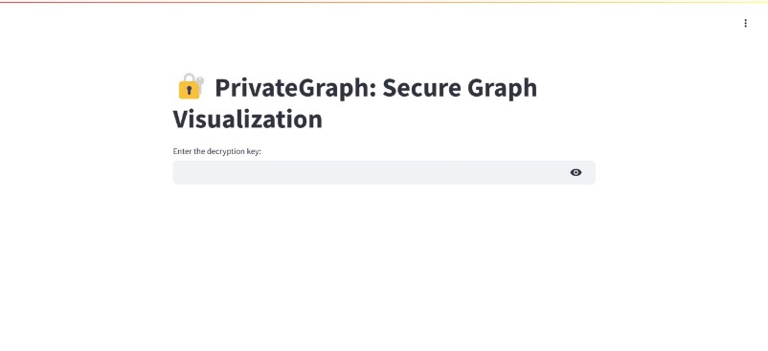

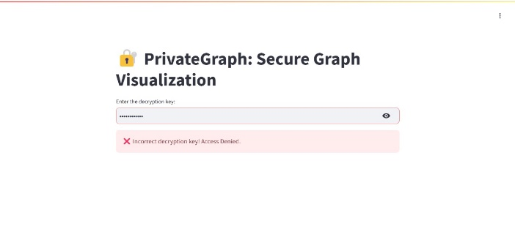

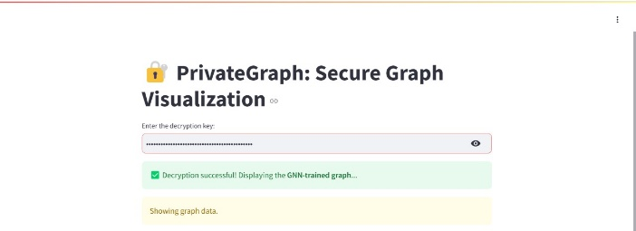

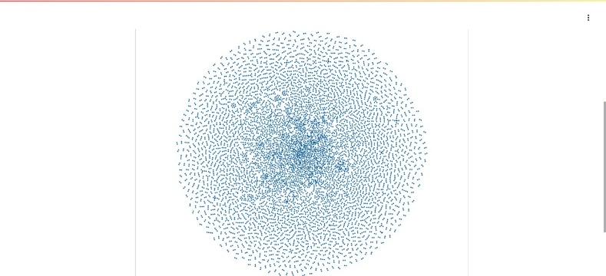

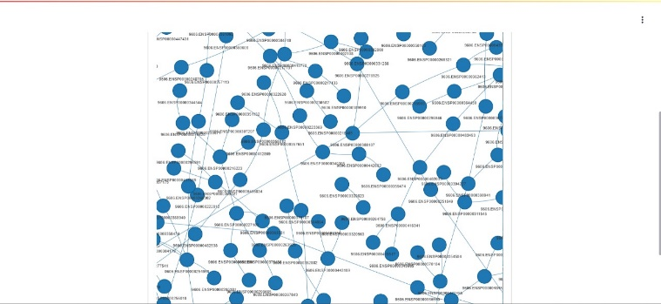

**Fig 5.4 Results**

# 6.CONCLUSION AND FUTURE SCOPE

## 6.1Conclusion

The Privacy-Preserving Spectral Analysis of Encrypted Graphs project showcases a scalable, secure, and usable system for performing graph-based machine learning on sensitive data such as bioinformatics and healthcare data. By synthesizing spectral graph theory, Graph Neural Networks (GNNs), and AES-GCM encryption, we have created a system that balances the need for privacy with data utility, addressing an oversized problem in modern data analytics. The system has demonstrated the ability to preprocess large-scale protein interaction data during the system design and implementation process, uses NetworkX to construct graphs, uses Laplacian decomposition to extract spectral features, and uses encryption that meets industry standards to encrypt features. We demonstrated that downstream applications can process the encrypted features, including node classification using a GCN model in PyTorch Geometric (PyG). Secure and interactive data visualization was accomplished using Streamlit and Pyvis using Cloudflared tunneling for secure and remote access.

The system has been thoroughly tested through unit, integration, system and user acceptance tests and found to be dependable and easy to use. The system supports end to end encrypted graph learning and visualization and retains confidentiality of raw data making it suitable in privacy alternative privacy-prolaying environments including healthcare analytics, biomedical analysis and regulatory compliance applications. Therefore, it can be concluded that the project lays a firm foundation for the future potential and expanding capabilities of secure graph analytics. Additionally, the implementation at this stage provides a sweet-spot between privacy and performance, with some enhancements - Feedback - differentially private, homomorphic encryption or federated learning, it could be possible to integrate the system into an entirely privacy preserving analytical system. Implementing the system to support the workflow of a l-scale sensitive graph structured data.

## 6.2Future Scope

The present deployment of the Privacy-Preserving Graph Spectroscopy Framework illustrates a solid basis for secure graph-based analytics, especially on sensitive areas such as healthcare and bioinformatics. Nevertheless, various improvements and extensions could be developed in subsequent work to further enhance the system's capabilities, strength, and use.

**1. Support for Advanced Privacy Techniques**

Though AES-GCM encryption yields secure and effective protection for spectral features, upcoming releases of the system may add Fully Homomorphic Encryption (FHE) or Differential Privacy in order to perform computation on top of encrypted data or add statistical privacy assurances. These features will make the system more robust to inference attacks as well as widen its compliance with changing privacy policies.

**2. Larger and Real-Time Dataset Support**

The system is now operational efficiently on graphs of medium size, like protein-protein interaction networks. Enhancements in the future can involve scaling the system for real-time processing of stream graph data or integration with real-time biomedical data streams. This would be particularly useful for clinical research platforms or genomic data banks that need constant analysis without affecting privacy.

**3. Improved GNN Architectures and Interpretability**

Subsequent versions of the project can delve deeper into more sophisticated GNN models like Graph Attention Networks (GATs) or hierarchical graph pooling techniques. Further, integrating explainable AI methods would enable health professionals and researchers to better understand GNN predictions with greater clarity and confidence.

**4. Web-Based Deployment and API Integration**

In order to enhance accessibility and usability, the system can be built as a fully deployable web-based platform with RESTful APIs to integrate into clinical decision systems, research portals, or biomedical informatics dashboards. This enables smooth interaction with the system without the need for users to run code locally.

**5. Automation of Compliance and Audit Logging**

Since the system operates on privacy-sensitive domains, some of the future features could be automated compliance verification, audit logs, and role-based access controls. These capabilities would make the system compliant with international data protection regulations such as GDPR, HIPAA, and CCPA, thus making it deployable for commercial and clinical purposes.

**6. Cross-Domain Adaptability**

The fundamental methodology of integrating spectral graph analysis with encryption and GNNs is not limited to healthcare. Such applications as financial fraud detection, secure social network analysis, cybersecurity, and supply chain risk modeling, all containing sensitive graph-structured data and needing privacy-preserving computation, are possible.

# REFERENCES

1. Sharma, S., Powers, J. and Chen, K., 2018. Private Graph: Privacy-preserving spectral analysis of encrypted graphs in the cloud. *IEEE Transactions on Knowledge and Data Engineering*, *31*(5), pp.981-995.
2. Sajadmanesh, S. and Gatica-Perez, D., 2021, November. Locally private graph neural networks. In *Proceedings of the 2021 ACM SIGSAC conference on computer and communications security* (pp. 2130-2145).
3. Ning, H., Udayashankar, S. and He, S.Q.K.K.X., 2021. Benchmarking differentially private graph algorithms. In *Workshop Theory and Practice of Differential Privacy, ICML*. JPC.
4. Li, J., Wei, J., Ye, M., Liu, W. and Hu, X., 2020. Privacy‐preserving constrained spectral clustering algorithm for large‐scale data sets. *IET Information Security*, *14*(3), pp.321-331.
5. Tarlow, D., Moitra, S., Rice, A., Chen, Z., Manzagol, P.A., Sutton, C. and Aftandilian, E., 2020, June. Learning to fix build errors with graph2diff neural networks. In *Proceedings of the IEEE/ACM 42nd international conference on software engineering workshops* (pp. 19-20).
6. Sharma, S., Powers, J. and Chen, K., 2016, May. Privacy-preserving spectral analysis of large graphs in public clouds. In *Proceedings of the 11th ACM on Asia conference on computer and communications security* (pp. 71-82).
7. Xie, P. and Xing, E., 2014. Cryptgraph: Privacy preserving graph analytics on encrypted graph. *arXiv preprint arXiv:1409.5021*.
8. Frikken, K.B. and Golle, P., 2006, October. Private social network analysis: How to assemble pieces of a graph privately. In *Proceedings of the 5th ACM workshop on Privacy in electronic society* (pp. 89-98).
9. Wang, H., Li, A., Shen, B., Sun, Y. and Wang, H., 2020. Federated multi-view spectral clustering. *IEEE Access*, *8*, pp.202249-202259.
10. Zhang, Y., Zhao, Y., Li, Z., Cheng, X., Wang, Y., Kotevska, O., Philip, S.Y. and Derr, T., 2024. A survey on privacy in graph neural networks: Attacks, preservation, and applications. *IEEE Transactions on Knowledge and Data Engineering*.